**2nd SEMESTER E-Project:**

Daily Shop

Group Students:

* **Ibad Mujahid**
* **M.Hassan**
* **M.Saqlain**
* **Syed M.Huzaifa**
* **Abdullah Muhammadi**

**Batch: 2112D**

**Faculty: Sir Saddam Hussain**

**TABLE OF CONTENTS**

|  |  |  |
| --- | --- | --- |
| S.No | Contents | Page No |
| 01 | Acknowledgment | 3 |
| 02 | Preface | 4 |
| 03 | Certificate Of Completion | 5 |
| 04 | Problem Definition | 6 |
| 05 | Project plan | 11 |
| 06 | Task Sheet | 12 |
| 07 | E-R Diagrams/Algorithms | 13 |
| 08 | Snapshots | 14 |
| 09 | Final Check List | 19 |
| 10 | Conclusion | 20 |

**ACKNOWLEDGMENT**

I would like to acknowledgment all those who have given memorial support and helped in making the E-Project success. I wish to express my gratitude to E-Project Team at Head Office who guided and helped me. Also, I would like to express my gratitude to all the staff Members of my Centre for not only providing me opportunity to work with them on this Project, but also for their support and encouragement throughout the process. I also Express my sincere gratitude to E-Project team from Aptech Head office and my Project Guide at the organization for his valuable guidance and support for completion of this Project. Final, I would like to offer many thanks to all my colleagues for their valuable suggestions and constructive feedback.

**Thanking you for all your support…**

“**First of all, we would like to thanks ALLAH the almighty, which give us mind to think and heart to fell Creativity. Creation depends on thinking”.**

**Preface**

Many people contributed to this project, and I would like to thank all of them. I guess I should start with my Faculty Sir **Saddam Hussain** of APTECH for his expert advice.

Very special thanks to our entire teachers who gave us valuable teaching and brilliant Suggestion and always encourage us to do the best. Indeed class fellows are very important and we would like to thank all of them for their kind appreciation, encouragement and moral support.

We would also like to express our deepest gratitude to our parents whose well wishes enabled us to transform our dream into a reality.

**Certificate**

This is certified that:

***“Ibad Mujhad / M.Saqlain/ SyedHuzaifa/M.Hassan****”*

Have successfully Design and Developed**.**

**Daily Shop**

Submitted ON:

**25/November/2022**

**Problem Definition**

## Introduction :

Arts is a stationary shop that sells arts, gift articles, greeting cards, dolls, files, hand bags, wallets, and as well some of the beauty products, etc…. As there is a lot of demand for the greeting cards, gift articles, hand bags, etc…. and in this busy world where one can hardly find time to go out for shopping and with the emerging new technologies where one can purchase products by placing an order through online by sitting at home/office either by credit cards or by VPP or through Cheque or through DD.

**Existing Scenario :**

Our client is a retail dealer of various products like gift articles, dolls, files, etc…. The customers usually visit the shop in order to purchase the products. He has a huge variety of products at his shop. Also as there is an increase in the demand of these products and as well as there is a huge variety of combinations and products available, and as the number of retail dealers are increasing day by day, it has become difficult to withheld in the market and as well to retain the customers.

Also as they don’t keep track of the products, it is hard to find how many products are available in the shop.

**Proposed Solution :**

In order to cope up in this competitive world, and to retain the customers, to automate the process, our client wants an application to be built meeting the current technology trend where the customers can place their order through online by sitting at their office/home, and providing the products as per the orders received by the dealer at the door steps of the customer.

He says that he wants that the application should hold the details of the products in detail like price, description of the product and each product is allocated with a unique 7 digit product id which includes 2 digit product code and 5 digit product number. Also he says that for fetching the details of the products, the customer need not be the registered one, but for placing an order one has to be the registered user of the site.

After placing an order, the dealer would dispatch the order as per the type of delivery that the customer has chosen. He says that the application should generate a unique 16 digit order number (includes the type of the delivery (1 digit) that the user has opted for, Product id (7 digit), and the order number (8 digit)) as soon as the order is placed by the customer.

For the order which is placed through the credit card payment or through cheque, the payment should be cleared first and then only the product will be dispatched to the customer’s premises. Also he has provided an option like if the customer is not satisfied by the product then the customer can either replace it (new product will not be sent) or he can return it back with in a week days time, so that he can get back his money which he has paid for that product. Also the warranty card will also be provided for the products which have some warranty.

The dealer alone should be able to update the details of the employees, products and their details, and he can check the orders that are received based on the date, order type (delivery) and he alone has the right to create an employee profile like username or login id and the password. The employee should only be able to change his password, and he can check the details of the orders so that the products can be dispatched as per the customer’s request and that they can be delivered in time.

Also he says that there should be an option on the web site where the customer can send their feedbacks regarding the services that they attain from them.

**Non-Financial :**

* **The dealer alone can manage the details of the products, employees and as well he can check the details of the orders, stock details, feedbacks and FAQ’s from the customers.**
* **The employee will only be able to change his/her password, and check and update the details of the orders and the delivery reports**
* **The details of the products, employees, orders, delivery/dispatching details and as well that of the customers, are needed to be maintained using the help of the database.**
* **Also the customer should be able to check the details of the order that he/she has placed.**
* **An advanced search option so as to fetch the details with an ease is to be implemented.**
* **The registered customers should alone be able to manage his/her account, orders placed by them and can check the details of the products while the non registered customers can only be able to check or fetch the details of the products and register with the site.**
* **The application should be automated, so that the details like the number of products that are available with them, dispatched details like when the product has been dispatched, the payment details, and the delivery details can be attained at an ease.**
* **The details of the payments at the time of placing an order should be captured in details based on the type of payment/dispatch that the customer is willing to have like the detailed description of the payments (credit card details if the payment is through the credit card, and cheque details if the payment is through cheque.**
* **The customer can only be able to cancel the order provided that the product is not dispatched from the dealer’s premises.**

**Financial :**

* For the customers who have placed an order for which the payment type is either through cheque or through credit card, only after the clearance of the payment the products will be dispatched.
* If the order placed is through VPP, the customer is needed to make the payment at the time of delivery at their premises.
* If the customer is not satisfied with the product then he can either place a request for replacing the product or he can return the product, so that he/she can get the payment back, provided the product is returned with in the week days time from the time of the delivery of the product at the customer’s premises.

**Functional Requirements**

* Maintaining the details of the Employees, product details, stock details, order, and delivery details of the products and that of the customers are to be maintained with the help of the database.
* There should be separate login for Admin, Employees and for the customer

**Project Plan**

Analysis 1-Day.

Design 3-Days

Developments 25-Days

Testing 4-HRS

Documentation 20-HRS

**Tasksheet**

|  |  |  |  |  |  |
| --- | --- | --- | --- | --- | --- |
| No | Tasks | Project Starting Date | Days of Task Complete | Group Members Names | Status |
| 1 | **Project Reading** | **26/Oct/2022** | **4-Days** | **ALL TEAM MEMBERS** | **Done** |
| 2 | **Back end work** | **1/Nov/2022** | **13-Days** | **ALL TEAM MEMBERS** | **Done** |
| 3 | **Website Interface Design** | **14/Nov/2022** | **2-Days** | **ALL TEAM MEMBERS** | **Done** |
| 4 | **Front end work** | **17/Nov/2022** | **2-days** | **ALL TEAM MEMBERS** | **Done** |
| 5 | **Final Testing** | **20/Nov/2022** | **2-Days** | **ALL TEAM MEMBERS** | **Done** |
| 6 | **Documentation** | **23/Nov/2022** | **1.5 Days** | **ALL TEAM MEMBERS** | **Done** |

**ER-Diagrams**

**Admin**

**USER**

Dashboard

HOME

Add Category

Contactu

US

Product

Add Product

USER

About US

US

Banner

US

**SNAP SHOTS OF WEBSITE**

**HOME**

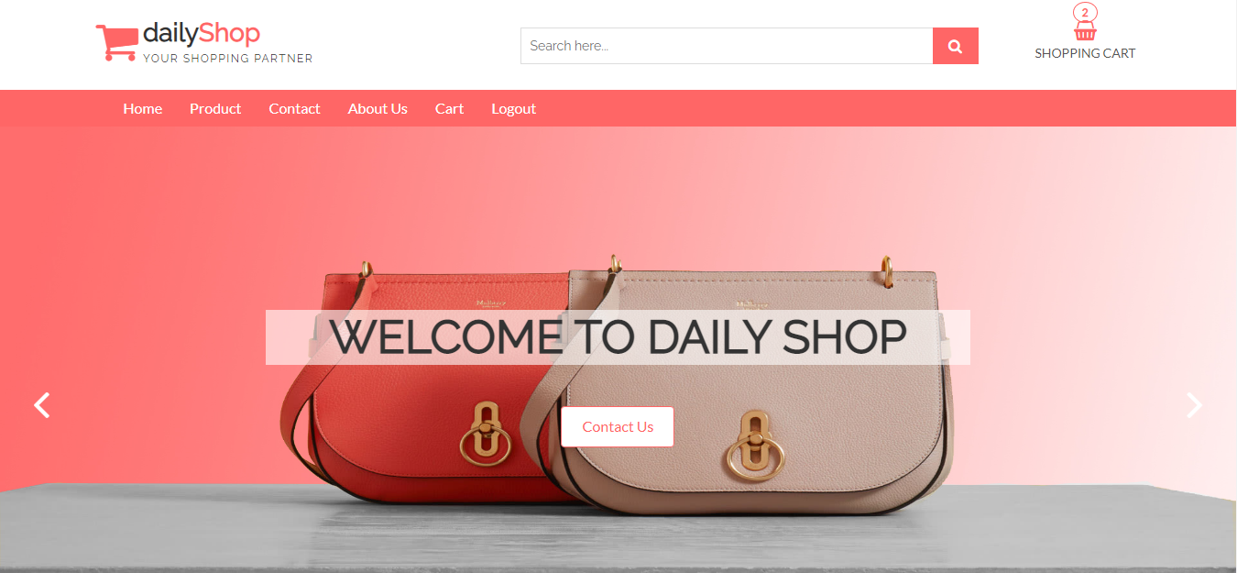

**ABOUT US**



**Login Page**

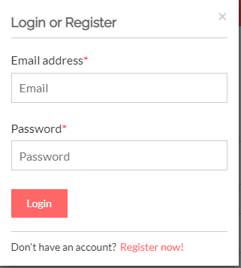

**Register Page**

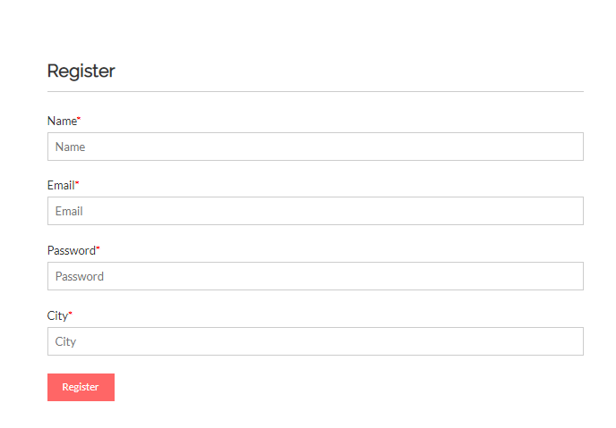

**Dashboard**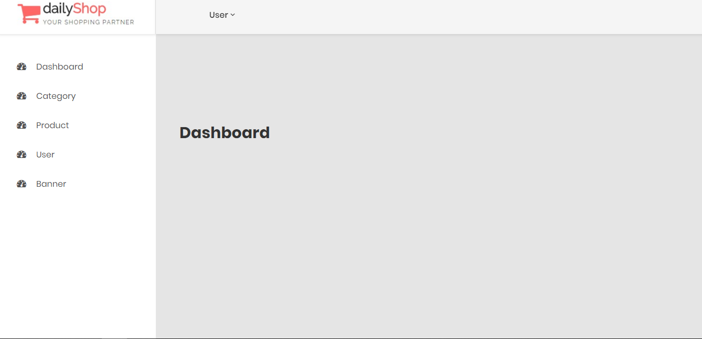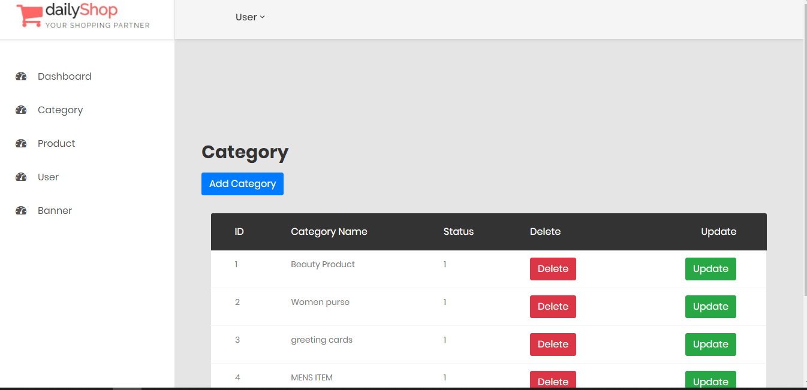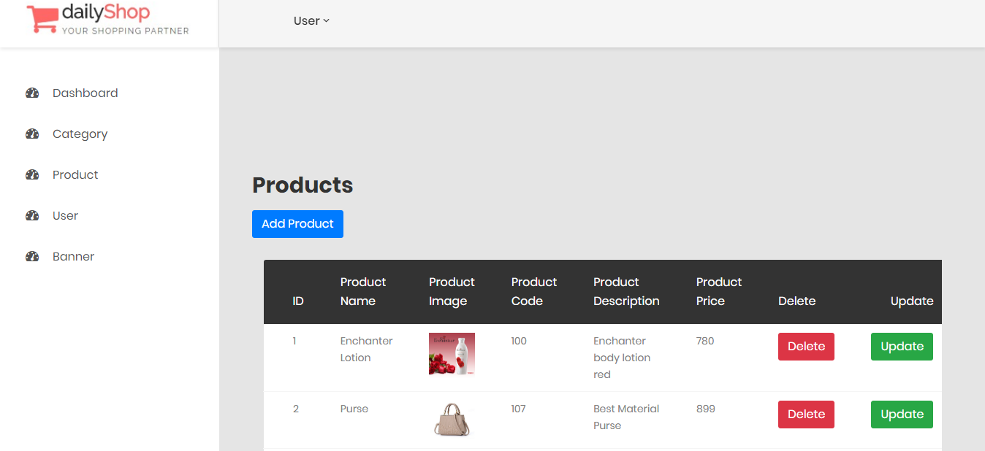

**CODE </>**

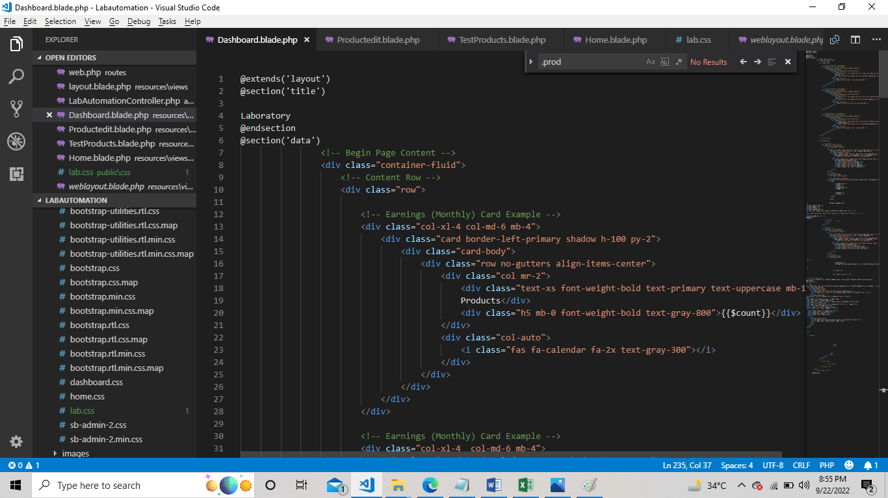**Final Checklist**

|  |  |  |
| --- | --- | --- |
| **Sr.No** | **Aspect Tested** | **Remarks** |
| 1 | Data Collection | Yes |
| 2 | Normalization | Yes |
| 3 | Designing Home Page | Yes |
| 4 | Developing Pages | Yes |
| 5 | Linking Pages | Yes |
| 6 | Finalizing the Site | Yes |
| 7 | Testing the Site | Yes |

**Conclusion**

In simple words, Strategic planning is a systematic process of deciding key decisions for an organization to thrive successfully in the next few years.

The planning process is a disciplined and time taking process produces fundamental decisions and actions that shape the organization.

**Thank You!!**